**Name: Quratulain sarwar**

**Intern ID: TN/IN02/PY/025**

**Task no: 3**

**Question 1:**

. Merge 2 files to one file with the name merged.txt. 2. Count lines/words/chars of the merged file

**Code:**

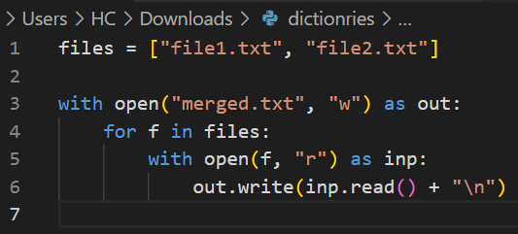

**Output:**

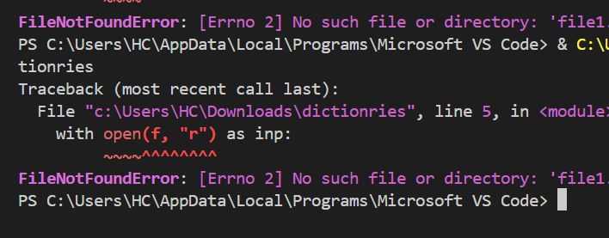

**Code 2:**

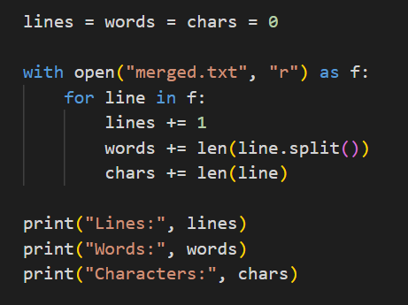

**Output:**

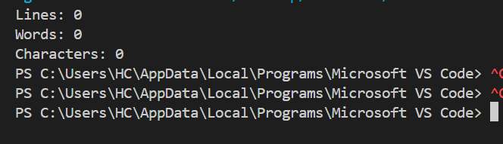

**Question 2:**

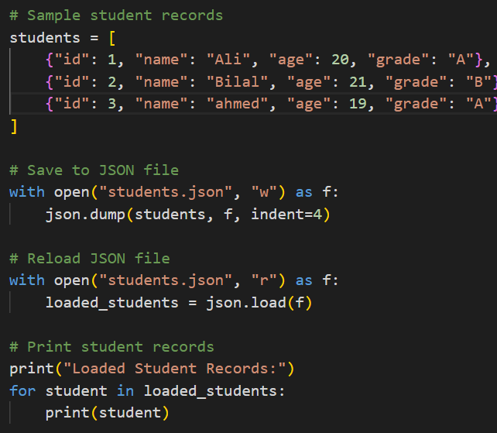

**Output:**

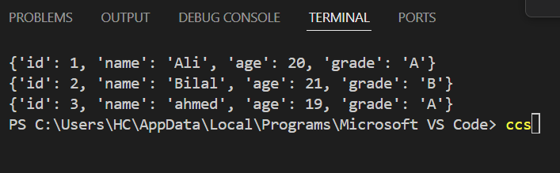

**Code 2:**

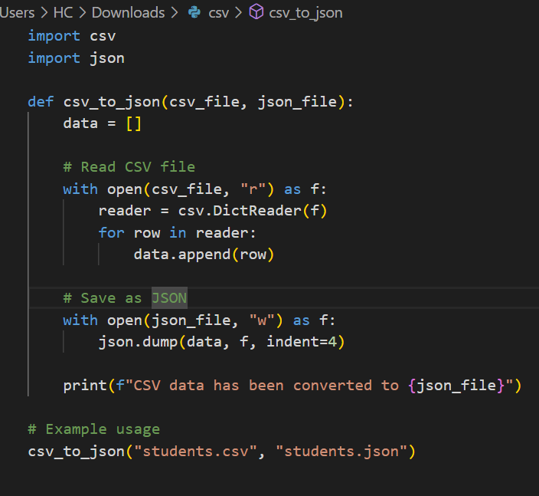

**Output;**

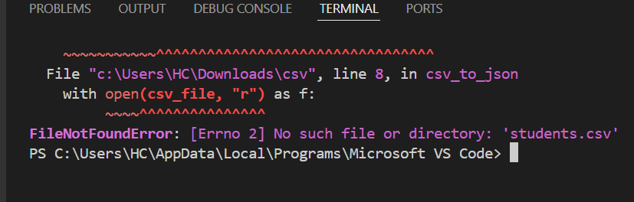

**Question 3:**

**Code:**

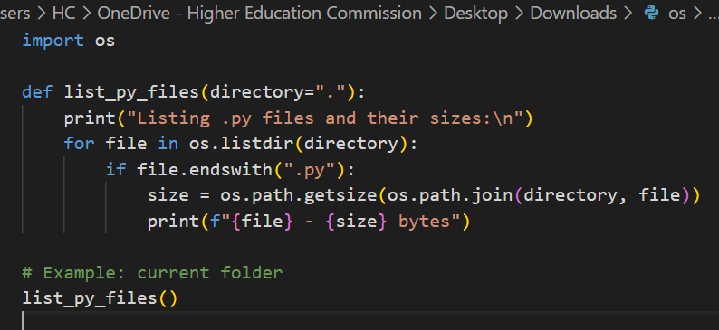

**Output:**

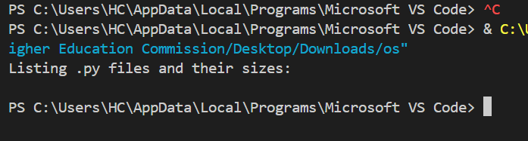

**Code 2:**

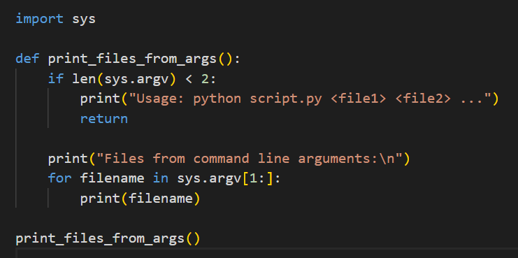

**Output:**

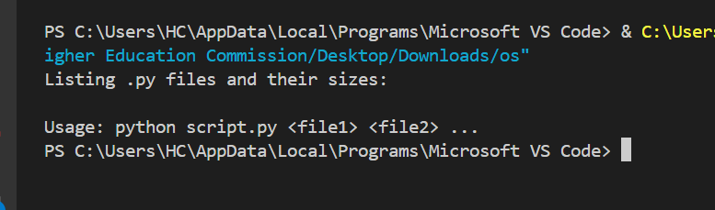

**Question 3 :**

**Code:**